Leyland TIP Options Recommendations

1. Context
In order to develop the Town Investment Plan (TIP) for Leyland we must present a set of shortlisted and agreed upon projects to Government. Our approach to shortlisting these projects must be well evidenced and in line with local ambitions for the town. In order to do this, and to articulate it clearly, a detailed evidence base assessment and set-by-step options process have been undertaken. The options assessment process and resulting project shortlist are presented in this document.

2. Shortlisting Approach
In order to shortlist the projects, the longlist options were assessed and RAG (Red-Amber-Green) rated against the assessment criteria detailed below. The longlist was drawn from Leyland’s readiness review presented to MHCLG in December 2019 as well as consultation with the Town Deal Board.
- Strategic Alignment – as defined following the board consultation exercise;
- Evidence of Need – drawing insights from the evidence base assessment;
- Impact – this is a judgement based on previous experience and the level of information available about projects at this stage;
- Estimated Costs – this is a judgement by the rough order of magnitude of costs specific costs will need to be developed through cost assessments and project development;
- Deliverability – assumed project delivery difficultly and project development stage;
- Timeline – the length of the delivery profile;
- Risk – including risk to value for money and delivery including Covid-19 impacts; and
- Covid-19 -including the projects contribution to recovery and the potential to explore any opportunities that arise as a result of Covid-19.
Based on the RAG ratings given project within scored and ranked (projects can be assigned a total of 24 points (or 3 per criteria) with rating of Red=1; Amber/Red=1.5; Amber=2 and Green=3). The total score of each project assessed is presented in the table below.
Table 1: the long list
Project Idea | Score | Rank
Skills shop - Building on SRBC's apprentice factory project development plan. There are local ambitions to deliver a skills hub for residents and businesses in the town centre. | 92% | 1
Town centre co-working space with start-up support - delivering a town centre space for start-up businesses and other workers potentially along with some business support services. | 83% | =2
Town centre masterplan - remodel & re-shape Leyland Town Centre to improve public realm and sense of centre | 83% | =2
Advanced manufacturing supply chain - exploring links/ partnership opportunities with AMRC/EZ activities in order to exploit advanced manufacturing supply chain opportunities. | 81% | =3
Virtual manufacturing hub - creating a virtual manufacturing hub to deliver training specifically focused on the advanced manufacturing sector. | 81% | =3
Regenerating the market building - physically improving the Council owned market building so that it is a more attractive place for local people to meet. | 79% | 4
Town centre events/ cultural space - delivery of a multi-use music/ events space in the town centre. This could be used/ leased for rehearsals, performances and meetings. | 75% | 5
Please note, where there is currently a lack of evidence and ‘Amber’ score has been given due to the uncertainty off this evidence gap however this may be subject to change following project development and detailed scoping. Also, a detailed breakdown of the scoring can be found in the options matrix appended.

3. Recommendations
Based on the scoring assessment the following project level recommendations are made. In addition, when drawing up the final shortlist efforts have been made to meet all the towns fund objectives and select projects that deliver different things. In addition, where possible project ideas have been merged to develop a longlist that will fully deliver the maximum possible impact utilising local insights and ideas.
Table 2: project level recommendations and shortlist
Project Idea | Score | Rank | Recommendations | Shortlist?
Skills shop | 92% | 1 | This project scores strongly against all criteria other there where there is an absence of project level detail. It aligns well with TIP objectives and there is clear evidence of need. It should be shortlisted. | YES - but skills shop and start-up support merged  ✔✔
Co-working space/ start-up support | 83% | =2 | This project scores strongly with evidence of need and strategic alignment. We recommend that it is merged with the skills shop projects so one physical space can deliver skills, business support and start-up space.
Town centre masterplan | 83% | =2 | This project is at a more advanced delivery stage with the masterplan currently undergoing consultation. We recommend that it forms the basis of the town centre improvement approach but focused down E.g. by merging Hough Lane improvements with the market hall regeneration to define a centre. | YES - but market building regen built from masterplan principles  ✔✔
Regenerating the market building | 79% | 4 | Though this project scores slightly less well in terms of economic impact improving Leyland's leisure offer and sense of place is central to local ambitions for the TIP. Leisure improvements should therefore be within the package of interventions. It is recommended that this be merged with the town centre masterplan project and brought into the shortlist.
Advanced manufacturing supply chain | 81% | =3 | This project has the potential to deliver significant impact for Leyland. However, delivery is less certain and would require significant engagement with potential partners do define an investment. We recommend it is progressed into the initial project development stage but with the understanding that further consultation should be explored before a decision regarding its inclusion in the final TIP | YES - but more scoping is required to confirm  ✔
Virtual manufacturing hub | 81% | =3 | Whilst this project scores well and has the potential to delivery impact a much more delivery skills focused project has also been shortlisted. In addition, similar to the Advanced Manufacturing supply chain project it would require significant consultation with partners and given time constraints it is recommended that efforts are focused on one project with greatest potential for impact. | NO  ✖
Town centre events/ cultural space | 75% | 5 | This project meets a similar need within the programme as the market building regeneration in terms of supporting Leyland's leisure offer but it is considered less deliverable as no specific building or location has yet been identified. It is therefore recommended that this project is not shortlisted at this time. | NO  ✖

4. The Shortlist
The recommended shortlisted projects for the Leyland TIP are as follows:
- Skills & Start-up Hub: A business focused skills and start-up hub in the town centre, ideally near Hough lane.
- Market Building Regeneration: Regeneration of the market building to create an improved leisure and night-time economy offer (labelled as ‘C’ on Figure 1).
- Advanced Manufacturing Supply Chain: Job creation and business start-up/ growth opportunities by tapping into the advanced manufacturing supply chain in collaboration with Uclan/ the EZ.
- Town Centre Transformation: A transformation of Hough Lane &/ Church Place to improve the quality of place, linking to the market building to define a centre (labelled as ‘A’ and ‘B’ on Figure 1). Some initial ideas around what this could look like are presented in Figure 2 and 3 but this will be subject to change through the project development stage.
Figure 1: Market Place and Hough Lane Masterplan Ideas
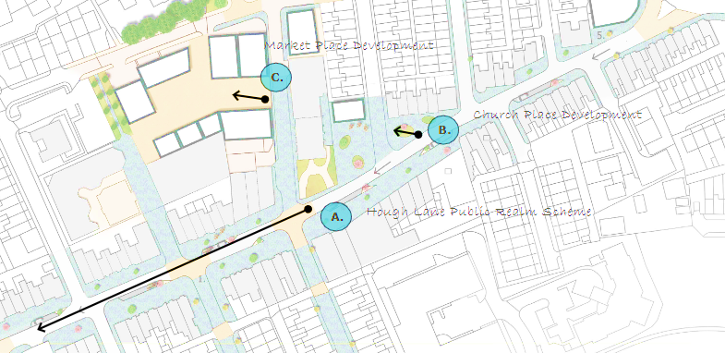
Source: WYG, 2020

Figure 2: Market Place (CGI)
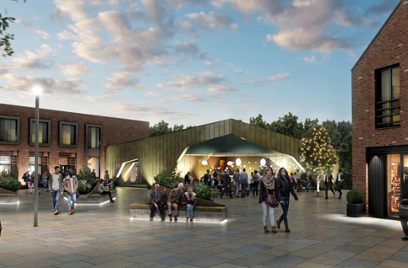
Source: WYG 2020
Figure 3: Leyland United Reform Church Place (CGI)

Source: WYG 2020

Appendices

Appendix 1 – Leyland Project Options Matrix Assessment

Appendix 2 – Leyland Project Scoping and Evidence Report

